Blackbox user guide

When the software begins, the system searches for the connected ‘black box’ hardware. If the hardware does not detect the proper ports connected, it will display an error message.

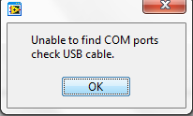

Once the Windows client has been started successfully, the first step is to *Collect information* from the UUT (unit under test).

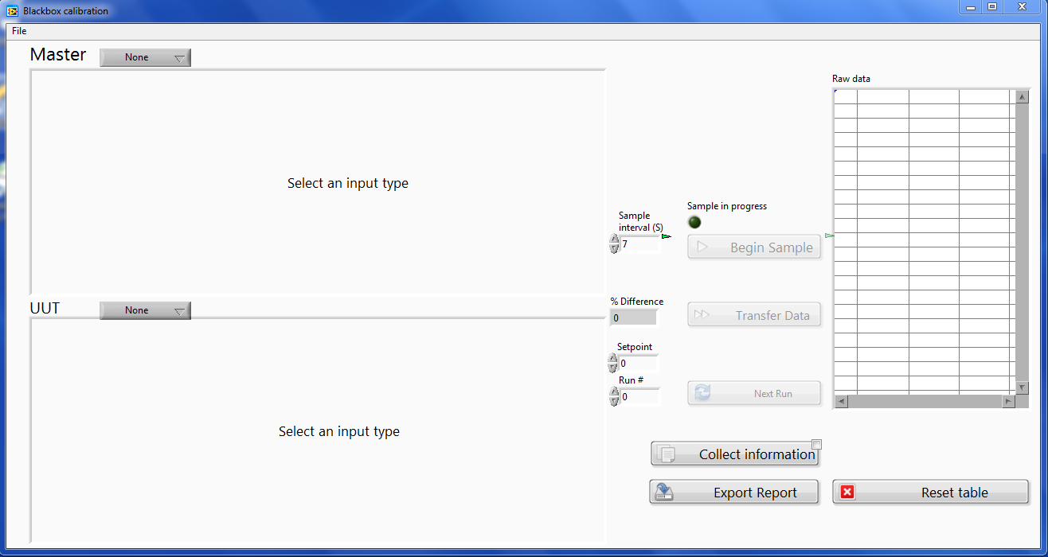

Three steps in the Collect Information window include selecting a protocol, pressing Sample, then Done.

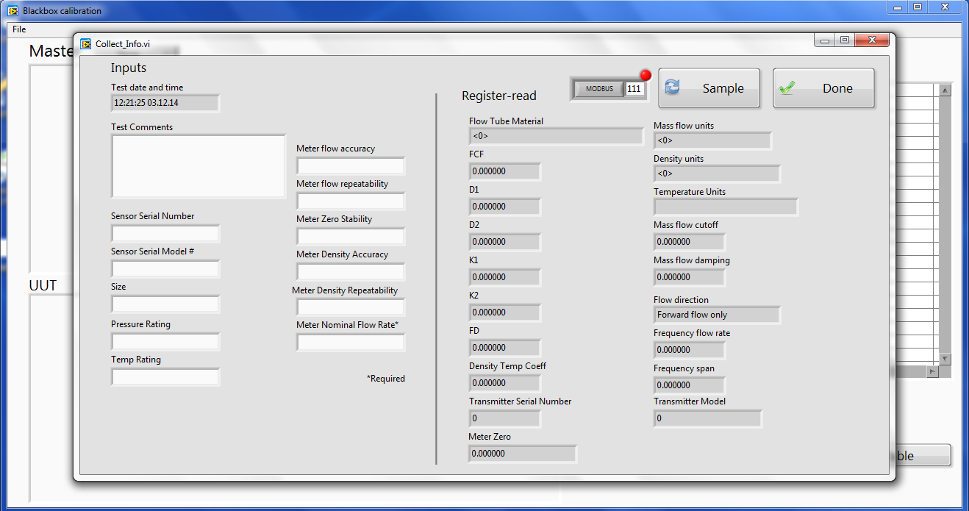

In the case that a red LED is lighted next to the protocol selection box is lit bright red, then an error is present on the bus. If the service port is being connected to, then MODBUS must be selected and address 111. Check the wiring polarity, and if an error is still present, then the RS485 ports may need reassignment. To swap the port assignment of the Master/UUT MODBUS ports, edit the file ‘config.txt’ with a text editor. This configuration file is located in [Program Files]/Calibrator/data/config.txt. Change/add the line Swap_MODBUS_Ports=True under the [Communication] section: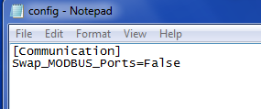

After the collection of information has been completed, the sampling functions are enabled.

Step 1 is to select the type of sample for both Master and UUT by selection from the drop-down box that, by default, reads “none”.

Step 2 is to enter a sample interval in seconds.

Step 3 is to ensure flow is going through both devices and set the ‘Setpoint’ control (0-100%).

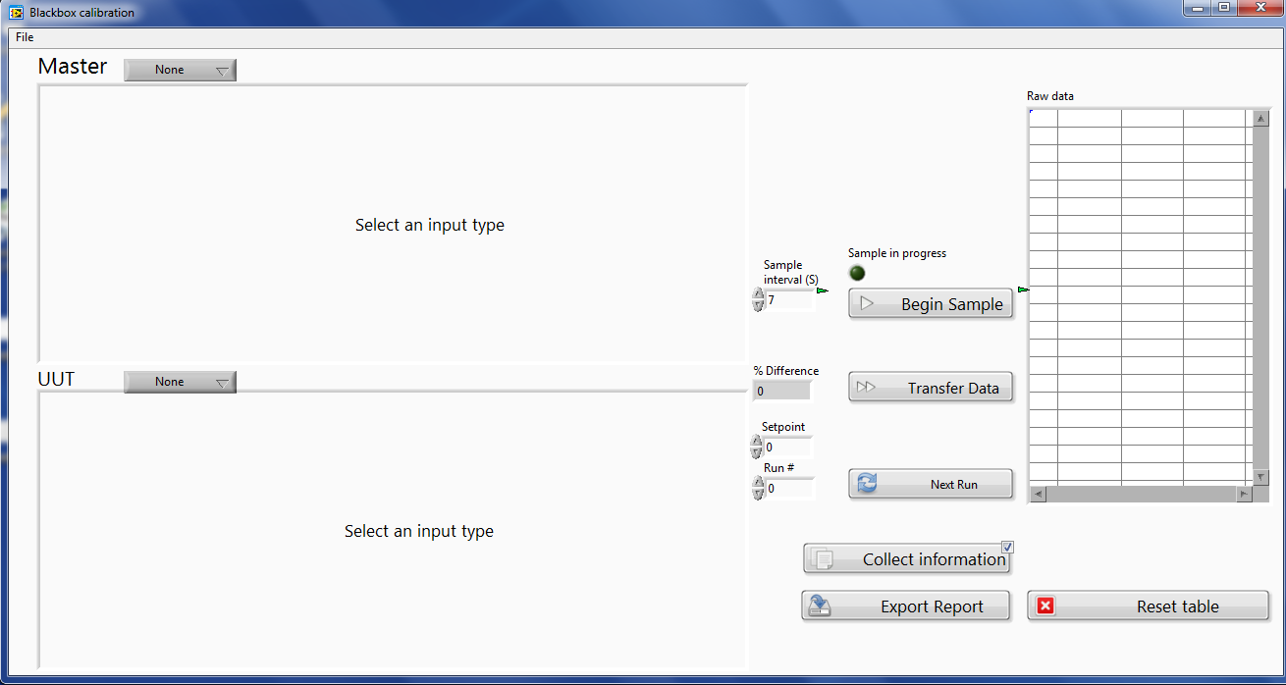

Step 4: select the units and scaling for each measurement type. In the example below, Pulse inputs are used in both cases- the scaling for the number of pulses per unit must be entered.

Step 5: Press Begin Sample and watch the Sample in Progress indicate when the test is complete.

Step 6: Press Transfer Data and the table will be populated with run #, setpoint, Master reading, and UUT reading.

Step 7: If this data is valid and the user wishes to move to the next run, press “Next Run” or increment the Run# manually. Move back to Step 3 and repeat until at least three samples have been acquired.

Step 8: When all data has been acquired, press ‘Export Report’ and allow the Excel software to open, set the values, and write the data.

